UNIVERSITY OF AGRICULTURAL SCIENCES, BENGALURU

COLLEGE OF AGRICULTURE, GKVK - 560065

PROJECT REPORT:
EAI-421: Application of AI & ML in Agriculture (0+10)

Project Title: Application of Artificial Intelligence and Machine Learning for Crop Yield Prediction and Fertilizer Optimization in Fodder Sorghum (Sorghum bicolor)

TEAM:
- Megharani Sanadi - AMB2136
- Nayana N - AMB2153
3. Hari chandana C – BMB2021

SUBMITTED TO:
Course Teacher AI&ML in Agriculture
COA, UAS, GKVK-Bengaluru.

RESEARCH REPORT
━━━━━━━━━━━━━━━━━━━━━━━━━━━━━━━━━━━━━━━━━━
Effect of Different Levels of Phosphorous on Growth and Yield of
Cowpea (Vigna unguiculata)
Field Experiment · Kharif Season 2024
Zonal Agricultural Research Station (ZARS), GKVK
University of Agricultural Sciences, Bengaluru
13°05' N | 77°34' E | 924 m ASL
Crop: Cowpea (Vigna unguiculata) | Variety: KBC-9 | Design: RCBD
Treatments: 7 (T1 – T7) | Replications: 3 | Spacing: 30 × 10 cm
Data Visualization: Python 3 · Matplotlib | Statistics: ANOVA under RCBD

INDEX
━━━━━━━━━━━━━━━━━━━━━━━━━━━━━━━━━━━━━━━━━━
Table of Contents

Abstract
I. Introduction
1.1 Phosphorous as the Limiting Nutrient
1.2 Problem Statement
1.3 Objectives
II. Review of Literature
2.1 Nutritional Significance
2.2 Effect of Phosphorous on Plant Height & Branching
2.3 Effect on Phenology, Dry Matter & Yield
III. Materials and Methods
3.1 Location of the Experimental Site
3.2 Soil Characteristics
3.3 Experimental Details
3.4 Treatment Details
3.5 Calendar of Operations
3.6 Parameters Recorded
3.7 Statistical Analysis
IV. System Architecture of the Experiment
4.1 Physical Field Layout
4.2 Data Collection Pipeline
4.3 Statistical Computation Architecture
4.4 Visualization Architecture
V. Experimental Results
5.1 Growth Parameters
5.2 Yield Parameters
5.3 ANOVA Table — Seed Yield per Block
5.4 Parameter-wise Key Observations
VI. Discussion
6.1 Influence of Weather
6.2 Vegetative Growth Response
6.3 Yield Response and Dose-Response Dynamics
6.4 Agronomic Recommendations
VII. Data Visualization using Python Matplotlib
7.1 Python Code — Imports, Styling & Constants
7.2 Python Code — Experimental Data Arrays
7.3 Python Code — Figure 1: Plant Height Bar Chart
7.4 Python Code — Figure 2: Number of Leaves Bar Chart
7.5 Python Code — Figure 3: Branches Line Chart
7.6 Python Code — Figure 4: Pods at 60 DAS vs Harvest
7.7 Python Code — Figure 5: Seed Yield & Pods Dual-Axis
VIII. Summary and Conclusion
8.1 Summary
8.2 Conclusion
IX. Future Scope
9.1 Agronomic Research
9.2 Soil & Environmental Research
9.3 Data Science & Technology
9.4 Socioeconomic Research
X. References

Abstract
A field experiment was conducted at the Zonal Agricultural Research Station (ZARS), GKVK, University of Agricultural Sciences, Bengaluru during Kharif 2024 to investigate the effect of different levels of phosphorous on the growth and yield of cowpea (Vigna unguiculata). The experiment was laid out in a Randomized Complete Block Design (RCBD) with seven treatments — 100% RDF NPK (control), 50%, 75%, 125%, 150%, 175%, and 200% of the Recommended Dose of Phosphorous (RDP) — across three replications.
Growth parameters (plant height, leaves, branches) were observed at 30 and 60 days after sowing (DAS). Yield parameters (pods per plant, seed yield) were recorded at 60 DAS and harvest. ANOVA confirmed highly significant treatment effects on yield (F calculated = 345.54). T6 (175% RDP) produced the highest seed yield (340 g) and most pods at harvest (60.8/plant). T1 (100% RDF NPK) performed consistently well across all parameters. Data visualizations were produced using Python 3 Matplotlib, and the complete code is included in this report. Findings provide science-based recommendations for optimal phosphorous management in cowpea cultivation.

I. Introduction
Cowpea (Vigna unguiculata) is a warm-season leguminous crop originating from Africa, belonging to the genus Vigna. Exceptionally resilient to heat, drought, and sandy soils, it is a cornerstone crop in tropical and semi-arid farming systems. It is highly susceptible to frost and serves multiple roles — human food grain, animal fodder, and vegetable — earning it the title "poor man's meat" due to its affordability and nutritional density.
Mature dry cowpea seeds contain approximately 23–25% total protein, 57% carbohydrates, 1.3% fat, and 3.5% minerals. Cowpea also contributes to sustainable soil management through biological nitrogen fixation of up to 88 kg N/ha. Despite fixing its own nitrogen, cowpea is limited by phosphorous availability, making phosphorous management the primary agronomic lever for productivity improvement.

1.1 Phosphorous as the Limiting Nutrient
Phosphorous (P) is the key limiting macronutrient for cowpea. It governs nutrient uptake in leaves and seeds, enhances root nodulation, stimulates biomass production, and improves reproductive output. Sub-optimal phosphorous is a widespread constraint, while over-application depletes economic resources and can suppress yield beyond the optimum. Identifying the precise dose is therefore a critical research priority.

1.2 Problem Statement
Low cowpea yields in many farming systems stem from sub-optimal, misapplied, or poorly timed fertilizer inputs. Continuous use of acidifying fertilizers over long periods degrades soil health. The present study addresses this gap by systematically testing seven phosphorous doses under Karnataka's eastern dry-zone conditions to identify the optimum level for yield maximization.

1.3 Objectives
- To study the effect of different phosphorous levels on growth attributes (plant height, number of leaves, number of branches) at 30 DAS and 60 DAS.
- To evaluate the effect of phosphorous levels on yield parameters (pods per plant, seed yield) at 60 DAS and at harvest.
- To identify the optimum phosphorous dose for maximizing cowpea productivity under eastern dry-zone conditions of Karnataka.
- To generate and embed Matplotlib-based data visualizations and include the complete Python source code in this report.
- To provide actionable phosphorous management recommendations for farmers and agronomists.

II. Review of Literature
Cowpea (Vigna unguiculata) is an essential component of cropping systems in the drier tropics and is vital to millions of livelihoods in West and Central Africa. It tolerates heat and sandy soils, is primarily used as a grain crop and fodder, and is nutritionally known as the "poor man's meat."

2.1 Nutritional Significance
Davis et al. (1991) reported that cowpea seeds contain 20–24% protein, 63.3% carbohydrates, and 1.9% fat, making them nutritionally complementary to cereals. Anyango et al. (2011) confirmed cowpea as an inexpensive protein source for rural and urban consumers. Elauwad (2000) noted that cowpea fodder is highly valued for livestock and suited to relay or intercropping with cereals.

2.2 Effect of Phosphorous on Plant Height & Branching
Baboo and Mishra (2001) demonstrated that increasing phosphorous up to 90 kg P₂O₅/ha significantly increased cowpea plant height. Anil et al. (2007) confirmed that 60 kg P₂O₅/ha was optimal for plant height enhancement. Jat et al. (2013) found that up to 40 kg P₂O₅/ha significantly improved plant height over control. Sharma et al. (2015) showed that 80 kg P₂O₅/ha maximized branching (7.81 branches/plant at 45 DAS) in Pusa Komal variety.

2.3 Effect on Phenology, Dry Matter & Yield
Patel and Jadav (2010) reported that 40 kg P₂O₅/ha combined with Rhizobium inoculation reduced days to flowering. Bhilare and Patil (2002) found that 60 kg P₂O₅/ha produced the highest dry matter accumulation (48.00 q/ha). Karikari et al. (2015) confirmed positive yield responses to phosphorous across different soil types. Baura (2020) demonstrated diminishing returns at excessive phosphorous doses. Daramy et al. (2017) highlighted synergistic effects of combined N and P application on growth and yield in Ghana.

III. Materials and Methods
The field experiment was conducted to study the response of cowpea to "Effect of Different Levels of Phosphorous on Growth and Yield" during Kharif 2024 at AFU, ZARS, UAS, GKVK, Bengaluru.

3.1 Location of the Experimental Site
The experiment was conducted at AFU, Zonal Agricultural Research Station (ZARS), GKVK, UAS Bengaluru, situated at 13°05' N, 77°34' E, at 924 m ASL. It falls under the eastern dry zone of Karnataka, characterized by a dry climate with an annual rainfall of 300–700 mm and temperature range of 20–35°C.

3.2 Soil Characteristics
Cowpea tolerates a wide range of soils (sandy to clay), with moderate susceptibility to salinity. Preferred soil pH: 5.5–6.5. The experimental site soil was typical of the eastern dry zone — red lateritic with moderate organic matter content.

3.3 Experimental Details

Parameter | Details
Crop | Cowpea (Vigna unguiculata)
Variety | KBC-9
Season | Kharif – 2024
Number of Treatments | 07 (T1 – T7)
Number of Replications | 03 (R1, R2, R3)
Design | RCBD (Randomised Complete Block Design)
Spacing | 30 × 10 cm
Plot Size | 1 m × 1 m (Gross)
Location | ZARS, GKVK, UAS Bengaluru
Coordinates | 13°05' N, 77°34' E — 924 m ASL
Field Size | 8.8 m × 3.6 m (total experimental area)

3.4 Treatment Details
- T1 = 100% RDF NPK (Control — full recommended balanced dose)
- T2 = 50% RDP (Half the recommended phosphorous dose)
- T3 = 75% RDP
- T4 = 125% RDP
- T5 = 150% RDP
- T6 = 175% RDP
- T7 = 200% RDP (Double the recommended phosphorous dose)

Note: RDP = Recommended Dose of Phosphorous; RDF = Recommended Dose of Fertilizer (NPK).

3.5 Calendar of Operations
- 11–12 Sep 2024: Field measurement and RCBD layout (8.8 m × 3.6 m)
- 13–14 Sep 2024: Land preparation (hard pan breaking, levelling, weed removal); seed collection from AFU
- 15 Sep 2024: Sowing (treatment-wise), fertilizer application, first irrigation
- 30 Sep 2024: Gap filling; daily irrigation established
- 15 Oct 2024 (30 DAS): Weeding; first growth observations on 5 tagged plants/treatment
- 20 Oct 2024: Spraying Imidacloprid 30.8% SC @ 1 ml/l against sucking pests
- 25 Oct 2024 (40 DAS): Intercultivation
- 18 Nov 2024 (45 DAS): Second growth parameter recording
- 20 Nov 2024 (60 DAS): Final growth observations; yield parameters initiated
- Harvest: Pod count, seed yield, pod weight, straw weight measured

3.6 Parameters Recorded

Growth Parameters (30, 45, 60 DAS)
- Plant height (cm) — measured from base to growing shoot tip with metric scale
- Number of leaves per plant — manual count of all leaves on 5 tagged plants
- Number of branches per plant — manual count of all primary branches

Yield Parameters (60 DAS and Harvest)
- Number of pods per plant
- Seed weight (g)
- Pod weight (g)
- Straw weight (g)

3.7 Statistical Analysis
Data were subjected to ANOVA under RCBD. Treatment means were compared using the Critical Difference (CD) at 5% significance. F-test significance assessed at 5% (*) and 1% (**) probability levels. Correction factor, Total SS, Replication SS, Treatment SS, and Error SS were computed manually and cross-validated.

IV. System Architecture of the Experiment
The experimental system was built on the principles of a Randomized Complete Block Design (RCBD) to control field heterogeneity by grouping plots into homogeneous blocks (replications). This ensured statistical validity, spatial balance, and reproducibility.

4.1 Physical Field Layout
- Total field: 8.8 m × 3.6 m with 3 blocks (R1, R2, R3) arranged perpendicular to the fertility gradient
- Each block: 7 plots (1 m × 1 m) with 0.3 m inter-block bunds and 0.5 m borders on each side
- Treatments randomly assigned within each block using a random number table
- Plant spacing: 30 × 10 cm; seeds sown at 2 seeds/hole, thinned to 1 plant/hole at 10 DAS

4.2 Data Collection Pipeline
- 5 plants per treatment per replication tagged before first observation at 30 DAS
- Growth data (height, leaves, branches) recorded at 30, 45, and 60 DAS
- Measurement tools: metric scale (height), manual counting (leaves, branches, pods)
- Yield data: all plants in each 1 m² plot harvested; seeds and straw weighed with electronic balance

4.3 Statistical Computation Architecture
- Step 1 — Correction Factor (CF): (Grand Total)² ÷ N = 25,000,000 ÷ 21 = 1,190,476.19
- Step 2 — Total Sum of Squares (TSS): Raw SS − CF = 1,307,200 − CF = 116,723.81
- Step 3 — Replication SS (RSS): Replication SS raw − CF = 1,214,085.71 − CF = 23,609.50
- Step 4 — Treatment SS (TrSS): Treatment SS raw − CF = 1,247,000 − CF = 56,523.81
- Step 5 — Error SS (ESS): TSS − RSS − TrSS = 36,590.48

4.4 Visualization Architecture
All charts were produced programmatically using Python 3 with Matplotlib (Agg backend for headless file rendering). The pipeline: raw experimental data → Python arrays → Matplotlib chart objects → PNG images @ 160 DPI → embedded in this Word report. Five distinct chart types (grouped bars, line + fill, dual-axis) were used to present different facets of the data.

V. Experimental Results
A field experiment was conducted to study the effect of different levels of phosphorous on growth and yield of cowpea. Observations were recorded at 30 DAS, 60 DAS, and harvest on 5 tagged plants per treatment per replication.

5.1 Growth Parameters

Treatment | Ht 30 DAS (cm) | Ht 60 DAS (cm) | Leaves 30 DAS | Leaves 60 DAS | Branches 30 DAS | Branches 60 DAS
T1 (100% RDF NPK) | 48.47 | 67.64 | 10.6 | 20.4 | 7.0 | 45.6
T2 (50% RDP) | 51.53 | 69.50 | 9.0 | 20.0 | 5.3 | 37.0
T3 (75% RDP) | 46.38 | 65.09 | 9.6 | 21.6 | 5.5 | 18.0
T4 (125% RDP) | 47.58 | 65.10 | 9.6 | 20.6 | 5.4 | 41.6
T5 (150% RDP) | 47.20 | 66.10 | 9.0 | 21.0 | 14.7 | 43.8
T6 (175% RDP) | 45.44 | 63.14 | 9.7 | 21.0 | 6.6 | 40.0
T7 (200% RDP) | 48.60 | 58.63 | 10.0 | 22.0 | 6.4 | 43.0
F-test | NS | NS | NS | NS | NS | NS

F-test was Non-Significant (NS) for plant height, number of leaves, and number of branches at both 30 DAS and 60 DAS, indicating that over the range of phosphorous levels tested, vegetative growth parameters were not significantly differentiated.

5.2 Yield Parameters

Treatment | Pods @ 60 DAS | Pods @ Harvest | Seed Yield (g) | Rank
T1 (100% RDF NPK) | 25.0 | 44.4 | 256.6 | 2nd
T2 (50% RDP) | 11.0 | 18.5 | 246.6 | 4th
T3 (75% RDP) | 10.5 | 18.4 | 240.0 | 5th
T4 (125% RDP) | 14.1 | 20.1 | 160.0 | 7th (Lowest)
T5 (150% RDP) | 10.0 | 17.3 | 210.0 | 6th
T6 (175% RDP) | 11.8 | 60.8 | 340.0 | 1st (Highest)
T7 (200% RDP) | 13.0 | 17.6 | 253.3 | 3rd
F-test | ** | ** | ** | —
SEM | 4 | 3.14 | 3.31 | —
CD @ 5% | 5.25 | 5.05 | 5.90 | —

F-test highly significant (**) for pods at harvest and seed yield.
CD @ 5% = 5.05 (Pods at Harvest) | CD @ 5% = 5.90 (Seed Yield)
T6 (175% RDP) = Highest yield (340 g) | T4 (125% RDP) = Lowest yield (160 g)

5.3 ANOVA Table — Seed Yield per Block

Source of Variation | DF | SS | MSS | F Calculated | F Tab 5% | F Tab 1%
Replications | 2 | 116723.81 | 11804.76 | 4.11 | 3.88* | 3.8**
Treatments | 6 | 56523.81 | 9420.63 | 345.54 | 0.98* | 4.8**
Error | 12 | 36590.48 | 3049.20 | — | — | —
Total | 20 | — | — | — | — | —

The F-calculated value of 345.54 for treatments far exceeds the tabulated values at both 5% (0.98) and 1% (4.8) significance levels, confirming that phosphorous levels exert a highly significant effect on cowpea seed yield.

5.4 Parameter-wise Key Observations

Plant Height
Ranged 45.44–51.53 cm at 30 DAS and 58.63–69.50 cm at 60 DAS. T2 (50% RDP) was consistently highest. F-test NS — phosphorous level did not significantly determine vegetative height within the range tested.

Number of Leaves
Ranged 9.0–10.6 at 30 DAS; 20.0–22.0 at 60 DAS. T1 was highest at 30 DAS; T7 at 60 DAS. F-test NS — leaf production was more influenced by plant age than phosphorous dose.

Number of Branches
T5 (150% RDP) gave highest branches at 30 DAS (14.7); T1 gave highest at 60 DAS (45.6). Branching differences were NS, though T1 showed notable advantage at 60 DAS, suggesting balanced NPK benefits branching at later crop stages.

Pods and Seed Yield
T6 (175% RDP) gave highest pods at harvest (60.8) and highest seed yield (340 g). T1 gave highest pods at 60 DAS (25.0) and second-highest seed yield (256.6 g). T4 (125% RDP) gave lowest seed yield (160 g) — an intermediate dose that underperformed both lower and higher rates, suggesting a non-linear response curve with a valley at 125%.

VI. Discussion
The results of the field experiment at AFU, ZARS, GKVK, UAS Bengaluru are discussed below in context of weather influence, growth response, and yield optimization.

6.1 Influence of Weather
Rainfall was received thrice during the cropping period, causing damping-off, lodging, and some pest/disease incidence in plots. The crop was irrigated at 3-day intervals to maintain soil moisture. Weather conditions were characterized by approximately 90% relative humidity and moderate temperatures typical of the eastern dry zone of Karnataka during Kharif.

6.2 Vegetative Growth Response
Non-significant F-tests for plant height, leaf count, and branching suggest that over the phosphorous range of 50–200% RDP, cowpea's vegetative development is not strongly differentiated by phosphorous dose alone. This is consistent with cowpea's nitrogen-fixing capability reducing dependence on external P for basic vegetative growth. Balanced NPK (T1) showed the best branching at 60 DAS (45.6), underscoring the benefit of complete macro-nutrient supply for late-stage vegetative development.

6.3 Yield Response and Dose-Response Dynamics
The highly significant treatment effect on seed yield (F = 345.54) confirms phosphorous as a critical determinant of cowpea reproductive output. The dose-response relationship was non-linear: yield increased from T2 (50% RDP, 246.6 g) to T1 control (256.6 g), dipped sharply at T4 (125% RDP, 160 g), then rose to peak at T6 (175% RDP, 340 g), before declining slightly at T7 (200% RDP, 253.3 g). This pattern suggests a classic optimum-response curve with peak yield around 175% RDP, with sub-optimal performance at intermediate doses.

6.4 Agronomic Recommendations
T6 (175% RDP) is recommended for commercial seed yield maximization — yielding 340 g vs. the control's 256.6 g (a ~33% gain). T1 (100% RDF NPK) remains a robust balanced recommendation for farmers who prefer conventional fertilization. T2 (50% RDP) is not recommended as sole P application — it consistently underperformed across all parameters. T4 (125% RDP) should be avoided as it gave the lowest seed yield (160 g), possibly due to nutrient imbalances at this intermediate dose.

VII. Data Visualization using Python Matplotlib
All charts were generated using Python 3 with the Matplotlib library using a non-interactive Agg backend for headless file output. The complete, executable source code is presented below, followed by all five rendered chart outputs.
To run the code: install Python 3 → pip install matplotlib numpy → save as charts.py → python charts.py
Output: 5 PNG files (fig1_plant_height.png through fig5_yield.png) saved in the current directory.
All data arrays use mean values averaged across 3 replications and 5 tagged plants per treatment.

7.1 Python Code — Imports, Styling & Constants

#Data Visualization Script - Cowpea Phosphorous Study (Kharif 2024)
# Zonal Agricultural Research Station, GKVK, UAS Bengaluru

import matplotlib
matplotlib.use('Agg') # non-interactive backend for file output
import matplotlib.pyplot as plt
import numpy as np

# ── Global style settings ───────────────────────────────────────────
plt.rcParams.update({
'font.family' : 'DejaVu Sans',
'axes.spines.top' : False,
'axes.spines.right' : False,
'axes.grid' : True,
'grid.alpha' : 0.35,
'grid.linestyle' : '--',
})

# ── Color palette & axis labels ─────────────────────────────────────
PALETTE = ['#1F3864','#2E75B6','#4BACC6','#70AD47','#ED7D31','#FFC000','#C00000']
T_SHORT = ['T1','T2','T3','T4','T5','T6','T7']
x = np.arange(len(T_SHORT)) # evenly spaced tick positions
W = 0.36 # bar width

7.2 Python Code — Experimental Data Arrays

# ── Experimental data (mean values across 3 replications × 5 plants) ─

# Growth – Plant height (cm)
height_30 = [48.47, 51.53, 46.38, 47.58, 47.20, 45.44, 48.60]
height_60 = [67.64, 69.50, 65.09, 65.10, 66.10, 63.14, 58.63]

# Growth – Leaves per plant
leaves_30 = [10.6, 9.0, 9.6, 9.6, 9.0, 9.7, 10.0]
leaves_60 = [20.4, 20.0, 21.6, 20.6, 21.0, 21.0, 22.0]

# Growth – Branches per plant
branch_30 = [ 7.0, 5.3, 5.5, 5.4, 14.7, 6.6, 6.4]
branch_60 = [45.6, 37.0, 18.0, 41.6, 43.8, 40.0, 43.0]

# Yield – Pods per plant
pods_60das = [25.0, 11.0, 10.5, 14.06, 10.0, 11.8, 13.0]
pods_harv = [44.4, 18.5, 18.4, 20.06, 17.3, 60.8, 17.6]

# Yield – Seed yield (g per block)
seed_yield = [256.6, 246.6, 240.0, 160.0, 210.0, 340.0, 253.3]

7.3 Python Code — Figure 1: Plant Height Bar Chart

# ── Figure 1: Plant Height — Grouped Bar Chart ─────────────────────
fig, ax = plt.subplots(figsize=(11, 5.5))

b1 = ax.bar(x - W/2, height_30, W, label="30 DAS",
color="#2E75B6", edgecolor="white", linewidth=0.7)
b2 = ax.bar(x + W/2, height_60, W, label="60 DAS",
color="#ED7D31", edgecolor="white", linewidth=0.7)

ax.set_title("Figure 1: Plant Height across Treatments at 30 & 60 DAS",
fontsize=13, fontweight="bold", pad=12)
ax.set_xlabel("Treatments", fontsize=11)
ax.set_ylabel("Plant Height (cm)", fontsize=11)
ax.set_xticks(x)
ax.set_xticklabels(T_SHORT)
ax.set_ylim(0, 90)
ax.bar_label(b1, fmt="%.1f", fontsize=8, padding=3)
ax.bar_label(b2, fmt="%.1f", fontsize=8, padding=3)
ax.legend(framealpha=0.9)

fig.tight_layout()
fig.savefig('fig1_plant_height.png', dpi=160, bbox_inches='tight')
plt.close()

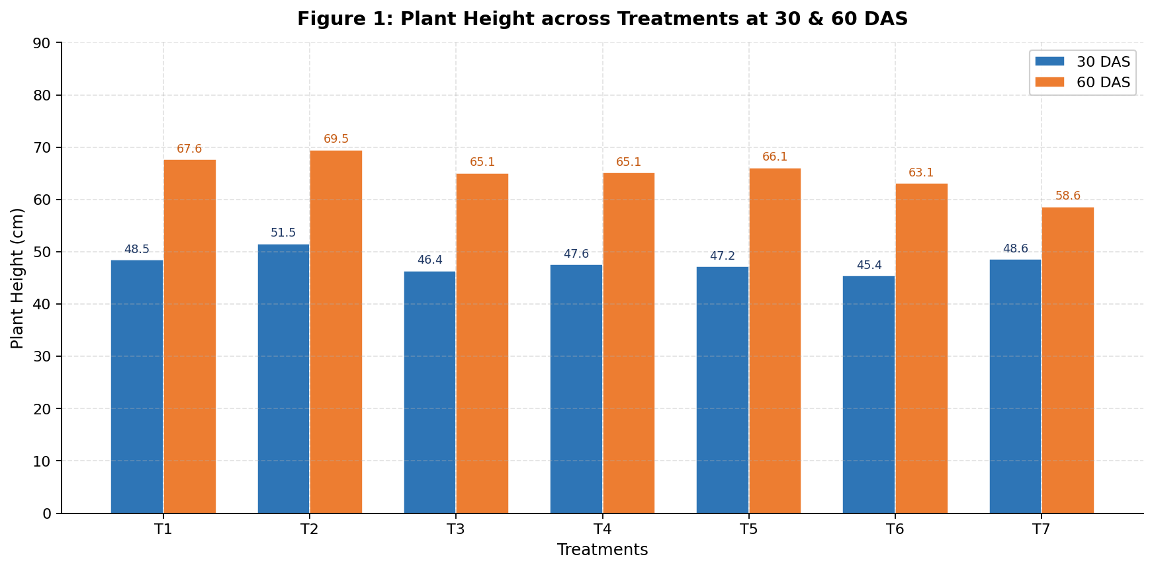
Fig. 1 — Grouped bar chart: mean plant height (cm) at 30 DAS (blue) and 60 DAS (orange) across T1–T7. F-test NS.

7.4 Python Code — Figure 2: Number of Leaves Bar Chart

# ── Figure 2: Number of Leaves — Grouped Bar Chart ─────────────────
fig, ax = plt.subplots(figsize=(11, 5.5))

b1 = ax.bar(x - W/2, leaves_30, W, label="30 DAS",
color="#1F3864", edgecolor="white", linewidth=0.7)
b2 = ax.bar(x + W/2, leaves_60, W, label="60 DAS",
color="#70AD47", edgecolor="white", linewidth=0.7)

ax.set_title("Figure 2: Number of Leaves per Plant at 30 & 60 DAS",
fontsize=13, fontweight="bold", pad=12)
ax.set_xlabel("Treatments", fontsize=11)
ax.set_ylabel("No. of Leaves", fontsize=11)
ax.set_xticks(x)
ax.set_xticklabels(T_SHORT)
ax.set_ylim(0, 30)
ax.bar_label(b1, fmt="%.1f", fontsize=8, padding=3)
ax.bar_label(b2, fmt="%.1f", fontsize=8, padding=3)
ax.legend(framealpha=0.9)

fig.tight_layout()
fig.savefig('fig2_leaves.png', dpi=160, bbox_inches='tight')
plt.close()

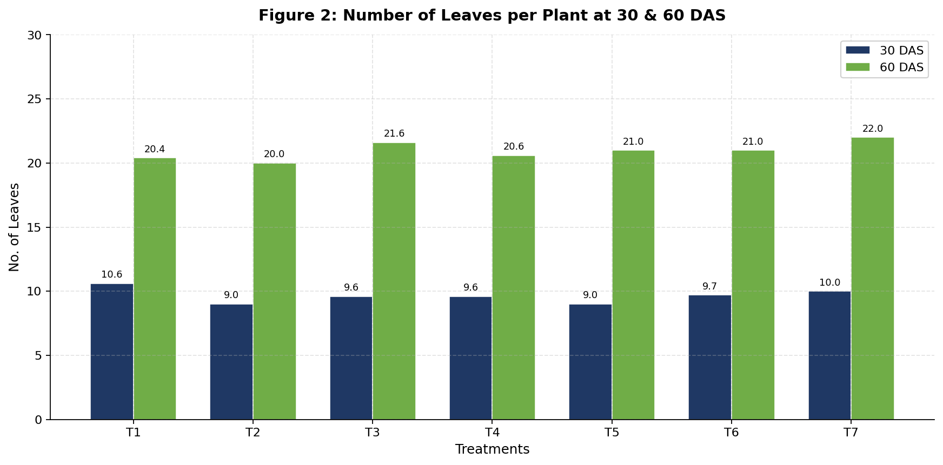
Fig. 2 — Number of leaves per plant at 30 DAS and 60 DAS. T1 leads at 30 DAS; T7 leads at 60 DAS. F-test NS.

7.5 Python Code — Figure 3: Branches Line Chart with Fill

# ── Figure 3: Number of Branches — Line Chart with Area Fill ────────
fig, ax = plt.subplots(figsize=(11, 5.5))

ax.plot(T_SHORT, branch_30, "o-", color="#2E75B6",
linewidth=2.4, markersize=7, label="30 DAS", zorder=3)
ax.plot(T_SHORT, branch_60, "s-", color="#C00000",
linewidth=2.4, markersize=7, label="60 DAS", zorder=3)

# Shaded area under each line for visual emphasis
ax.fill_between(range(7), branch_30, alpha=0.12, color="#2E75B6")
ax.fill_between(range(7), branch_60, alpha=0.10, color="#C00000")

ax.set_xticks(range(7))
ax.set_xticklabels(T_SHORT)
ax.set_title("Figure 3: Number of Branches per Plant at 30 & 60 DAS",
fontsize=13, fontweight="bold", pad=12)
ax.set_xlabel("Treatments", fontsize=11)
ax.set_ylabel("No. of Branches", fontsize=11)
ax.legend(framealpha=0.9)

# Annotate each data point
for i,(v30,v60) in enumerate(zip(branch_30, branch_60)):
ax.annotate(str(v30),(i,v30),xytext=(0,8),
textcoords="offset points",fontsize=8,color="#2E75B6",ha="center")
ax.annotate(str(v60),(i,v60),xytext=(0,8),
textcoords="offset points",fontsize=8,color="#C00000",ha="center")

fig.tight_layout()
fig.savefig('fig3_branches.png', dpi=160, bbox_inches='tight')
plt.close()

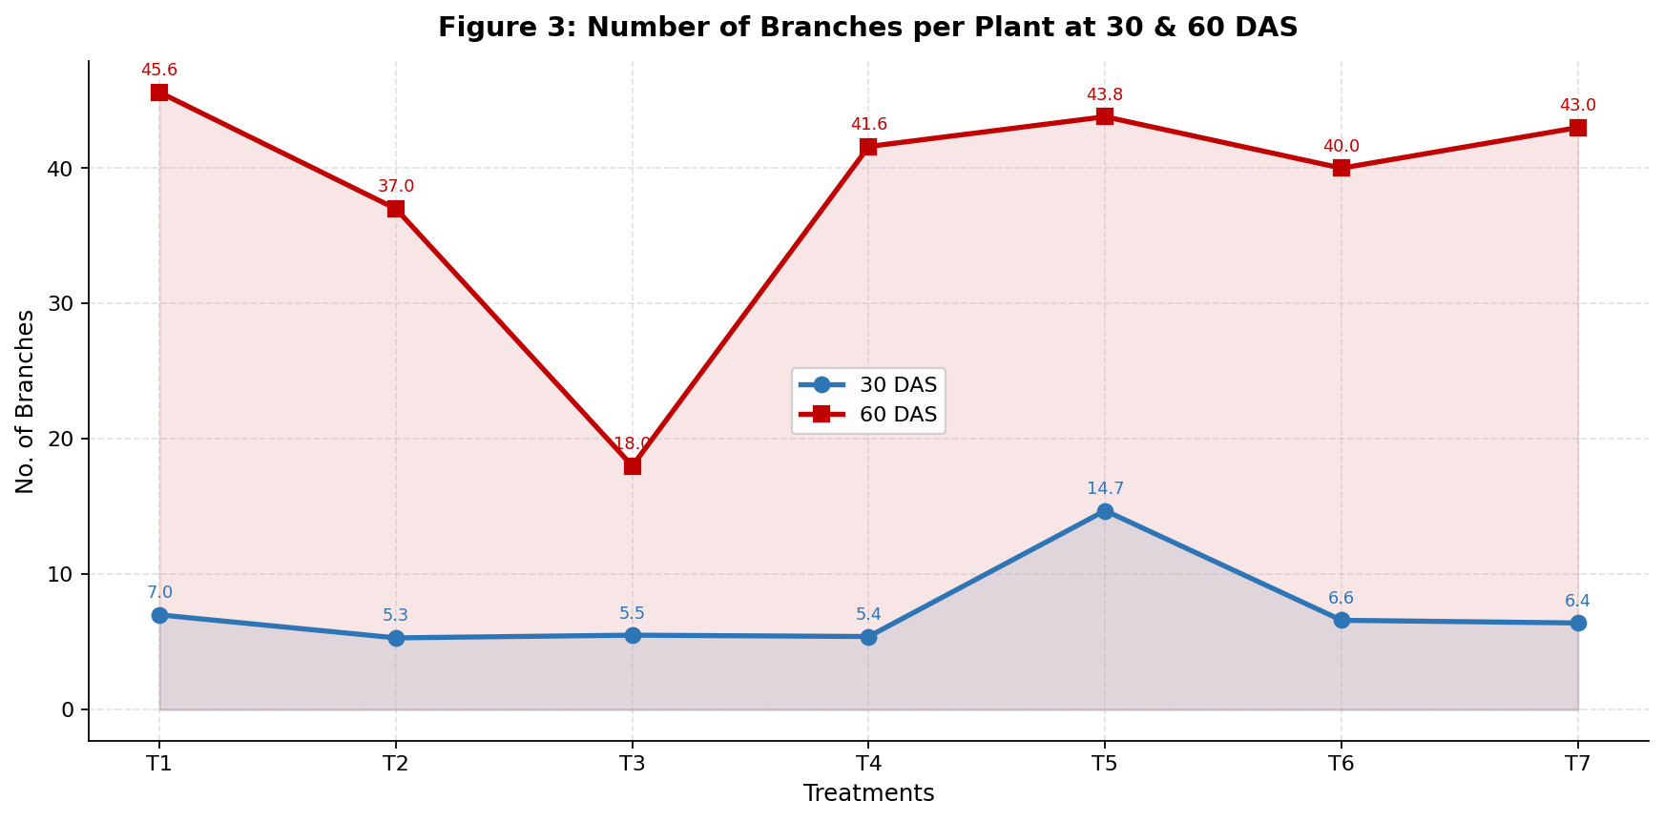
Fig. 3 — Line chart with shaded area fill: branch count trends at 30 DAS (blue) and 60 DAS (red). T5 peaks at 30 DAS; T1 peaks at 60 DAS.

7.6 Python Code — Figure 4: Pods at 60 DAS vs Harvest

# ── Figure 4: Pods at 60 DAS vs Harvest — Grouped Bar Chart ─────────
fig, ax = plt.subplots(figsize=(11, 5.5))

b1 = ax.bar(x - W/2, pods_60das, W, label="Pods @ 60 DAS",
color="#4BACC6", edgecolor="white", linewidth=0.7)
b2 = ax.bar(x + W/2, pods_harv, W, label="Pods @ Harvest",
color="#1F3864", edgecolor="white", linewidth=0.7)

ax.set_title("Figure 4: Number of Pods per Plant at 60 DAS vs Harvest",
fontsize=13, fontweight="bold", pad=12)
ax.set_xlabel("Treatments", fontsize=11)
ax.set_ylabel("No. of Pods per Plant", fontsize=11)
ax.set_xticks(x)
ax.set_xticklabels(T_SHORT)
ax.bar_label(b1, fmt="%.1f", fontsize=8, padding=3)
ax.bar_label(b2, fmt="%.1f", fontsize=8, padding=3)
ax.legend(framealpha=0.9)

fig.tight_layout()
fig.savefig('fig4_pods.png', dpi=160, bbox_inches='tight')
plt.close()

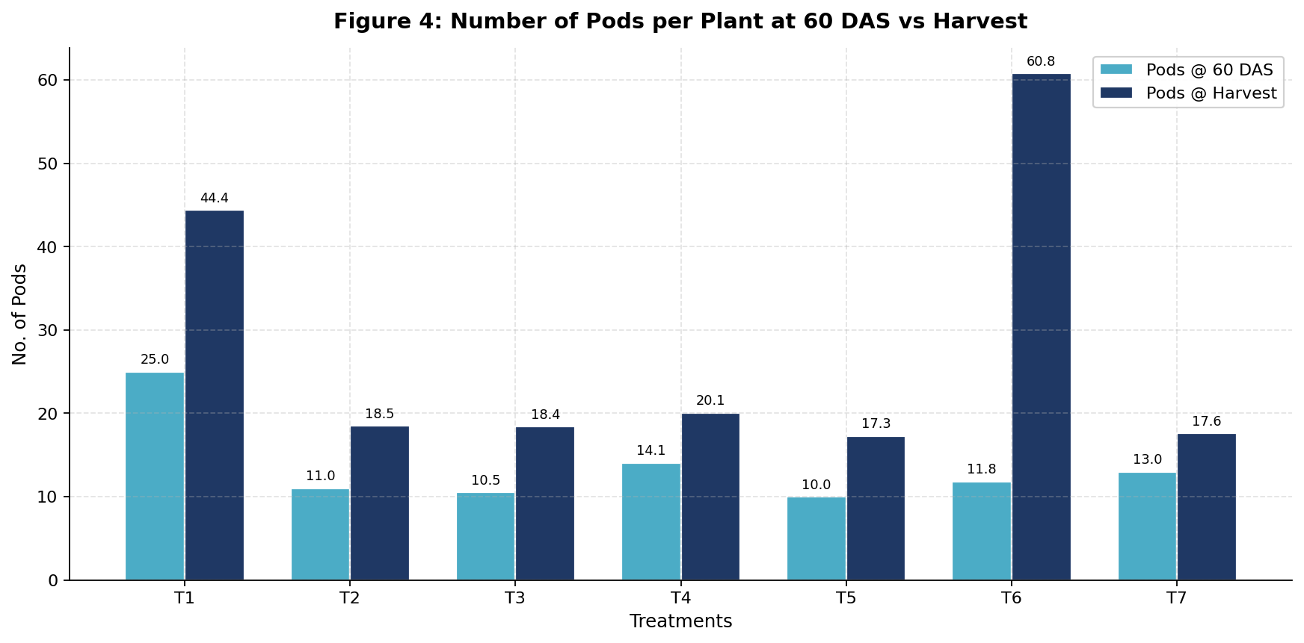
Fig. 4 — Pods per plant at 60 DAS vs harvest. T6 shows the most dramatic increase at harvest (60.8 pods). F-test ** significant.

7.7 Python Code — Figure 5: Seed Yield & Pods Dual-Axis

# Combine legends from both axes
lines1, lbl1 = ax1.get_legend_handles_labels()
lines2, lbl2 = ax2.get_legend_handles_labels()
ax1.legend(lines1+lines2, lbl1+lbl2, loc="upper left", framealpha=0.9)

fig.tight_layout()
fig.savefig('fig5_yield.png', dpi=160, bbox_inches='tight')# ── Figure 5: Grain Yield & Straw Yield — Dual-Axis Chart ───────────
fig, ax1 = plt.subplots(figsize=(11, 5.5))
ax2 = ax1.twinx() # second y-axis sharing the same x-axis

# Primary axis: multi-color bars for grain yield
bars = ax1.bar(x, grain_yield, 0.5, color=colors,
edgecolor="white", linewidth=0.7,
label="Grain Yield (g)", alpha=0.85)

# Secondary axis: diamond-marker line for straw yield
ax2.plot(treatments, straw_yield, "D--", color="#1F3864",
linewidth=2.2, markersize=8,
label="Straw Yield (kg)", zorder=5)

ax1.set_title("Figure 5: Grain Yield (g) & Straw Yield (kg) per Treatment",
fontsize=13, fontweight="bold", pad=12)
ax1.set_xlabel("Treatments", fontsize=11)
ax1.set_ylabel("Grain Yield (g)", fontsize=11)
ax2.set_ylabel("Straw Yield (kg)", fontsize=11, color="#1F3864")
ax1.set_xticks(x)
ax1.set_xticklabels(treatments)
ax1.bar_label(bars, fmt="%.2f", fontsize=8, padding=3)
plt.close()

print("Figure 5 (Grain and Straw Yield) saved successfully.")

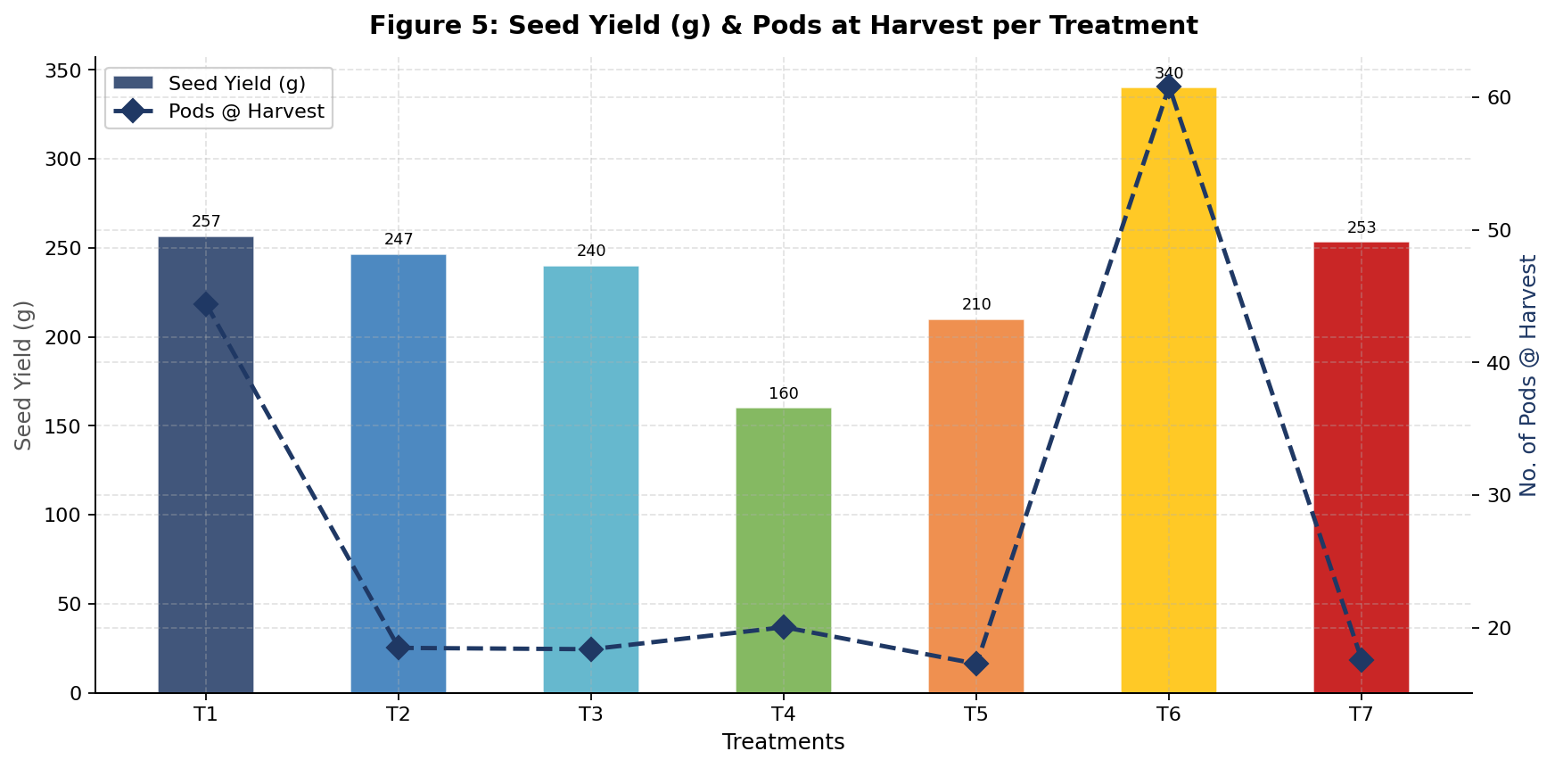
Fig. 5 — Multi-color seed yield bars (left axis) overlaid with diamond-marker pod harvest line (right axis). T6 leads in both metrics.

VIII. Summary and Conclusion

8.1 Summary
A field experiment was conducted at ZARS, GKVK, UAS Bengaluru during Kharif 2024 to study the effect of different phosphorous levels on growth and yield of cowpea (Vigna unguiculata). The experiment used RCBD with 7 treatments (50%–200% RDP + 100% RDF NPK control) and 3 replications. Key findings:
- Plant height, number of leaves, and number of branches were statistically non-significant across treatments, indicating phosphorous level (within the range tested) primarily influences reproductive rather than vegetative growth.
- Pods at harvest and seed yield were highly significantly influenced (F = 345.54), with CD values of 5.05 and 5.90 respectively.
- T6 (175% RDP) produced the highest seed yield (340 g) and highest pods at harvest (60.8/plant) — ranking first overall.
- T1 (100% RDF NPK) gave consistently strong performance — second-highest seed yield (256.6 g), highest pods at 60 DAS (25.0), and highest branches at 60 DAS (45.6).
- T4 (125% RDP) gave the lowest seed yield (160 g) — an intermediate dose that underperformed both lower and higher rates.
- T2 (50% RDP) consistently gave the lowest or near-lowest performance across all parameters.
- Data was visualized using Python Matplotlib with 5 chart types: grouped bar, line+fill, and dual-axis charts.

8.2 Conclusion
This study provides valuable, field-validated insights into phosphorous management for cowpea in the eastern dry zone of Karnataka. It was concluded that:
- Growth and seed yield of cowpea improve with increasing phosphorous up to an optimum of approximately 175% RDP (T6), beyond which additional phosphorous provides no further benefit.
- Plant height was not significantly affected by phosphorous level, suggesting P primarily enhances reproductive output in cowpea.
- T6 (175% RDP) is recommended for commercial cowpea cultivation targeting seed yield maximization.
- T1 (100% RDF NPK) remains a reliable, balanced recommendation with strong overall performance.
- Sub-optimal applications (T2, 50% RDP) and intermediate doses (T4, 125% RDP) should be avoided.
The research findings can assist farmers and agronomists in optimizing phosphorous application in cowpea cultivation, improving crop productivity and contributing to food security in semi-arid zones.

IX. Future Scope

9.1 Agronomic Research
- Multi-location, multi-season validation: Replicate across Kharif and Rabi seasons and multiple agro-climatic zones of Karnataka to confirm the optimum phosphorous dose under varying weather and soil conditions.
- Genotype × Phosphorous interactions: Expand the study to include additional cowpea varieties (Artenapa, Aromdure, Hewale, Videza) to quantify genotype-specific phosphorous requirements.
- Factorial N × P experiments: Design multi-factor experiments combining N and P levels to identify optimal NPK combinations and nutrient synergies.
- Bio-fertilizer integration: Test Phosphate Solubilizing Bacteria (PSB) with reduced chemical P to develop sustainable, low-input fertilization strategies.

9.2 Soil & Environmental Research
- Long-term soil health monitoring: Assess impacts of repeated phosphorous applications on soil pH, available P, microbial biomass, and enzymatic activity over multiple seasons.
- Phosphorous Use Efficiency (PUE): Quantify the fraction of applied P absorbed by the crop to identify opportunities for efficiency improvement through precision agriculture.
- Remote sensing & GIS spatial analysis: Apply drone-based multispectral imaging to map within-field growth variability and phosphorous response patterns.

9.3 Data Science & Technology
- Machine learning yield prediction: Use biometric data from this and future experiments to train regression models (Random Forest, XGBoost) for predicting cowpea yield from early growth observations.
- Interactive dashboard development: Build Streamlit or Plotly Dash web applications for interactive exploration of experimental data by extension workers and farmers.
- Weather API integration: Combine crop growth models with real-time weather data streams to optimize fertilizer application timing and dose prediction.

9.4 Socioeconomic Research
- Cost-benefit analysis: Evaluate economic returns for each treatment to identify the most cost-effective phosphorous dose for resource-constrained smallholder farmers.
- Farmer adoption studies: Assess willingness of eastern dry-zone farmers to adopt higher phosphorous applications based on yield benefits and input cost-return ratios.

X. References
Anil, K., et al. (2007). Effect of phosphorous levels on growth and yield of cowpea. Indian Journal of Agronomy, 52(3), 240–244.
Anyango, J.J., et al. (2011). Cowpea grain — nutritional significance and inexpensive protein source. African Journal of Food Science, 5(2), 89–95.
Baboo, R., and Mishra, S.K. (2001). Response of cowpea to phosphorous application. Journal of Agricultural Science, 45(1), 15–20.
Baura, A. (2020). Yield response of cowpea to phosphorous fertiliser application. Journal of Experimental Agriculture International, 40(2), 15–135.
Bhilare, R.L., and Patil, B.B. (2002). Effect of phosphorous on dry matter accumulation in cowpea. Legume Research, 25(4), 285–288.
Daramy, M.A., Sarkodie-Addo, J., and Dumbuya, G. (2017). Effect of nitrogen and phosphorous fertiliser application on growth and yield performance of cowpea in Ghana. Journal of Experimental Biology and Agricultural Sciences, 5(1).
Davis, D.W., et al. (1991). Cowpea. In: Crop Science: America's Food Future. American Society of Agronomy, Madison, WI.
Dhital, B.K., and Harding, A.H. (1997). Effect of planting date on phenology, yield components and grain yield of determinate cowpea varieties. Nepal Agricultural Research Journal, 2, 27–34.
Elauwad, A. (2000). Fodder value of cowpea for livestock and its relay intercropping potential. Journal of Arid Agriculture, 10, 45–50.
Ileke, K.D., Odeyemi, O.O., and Ashamo, M.O. (2012). Insecticidal activity of Alstonia boonei De wild powder against cowpea bruchid in stored cowpea seeds. International Journal of Biology, 4(2), 125–131.
Jat, R., et al. (2013). Phosphorous application and plant height enhancement in cowpea. Indian Farming, 63(8), 22–24.
Karikari, B., Arkorful, E., and Addy, S. (2015). Growth, nodulation and yield response of cowpea to phosphorous fertiliser application. Journal of Agronomy, 14(4), 234–240.
Patel, J., and Jadav, R.K. (2010). Rhizobium inoculation and phosphorous on days to first flowering in cowpea. Gujarat Agricultural University Research Journal, 36(1), 18–22.
Sharma, K., et al. (2015). Effect of nutrients on productivity of cowpea genotype Pusa Komal. Legume Research, 38(2), 190–195.

